**Napier University**

16

**Treasure Hunters App**

**Python Application Report**

**Katarzyna Gniady-Brzoza**

Contents

1. Overview 2

2. Software Design 3

2.1 Application Development 3

3. Application Evaluation 4

3.1 Critical Evaluation 4

3.2 Personal Evaluation 4

4. Application Screenshots 6

5. References and Resources 15

# Overview

I was asked to create an online application, which should be designed with Python and run within Levinux Environment using Flask Library. The application should use python programing but can also include other languages such as HTML, JavaScript or CSS. The choice of the application was up to me, I could choose any topic which I am interested in or which I wanted to present.

I decided to choose the application which allows the user to interact with it in a very easy way. This application was designed for learning purpose and can be viewed and downloaded from my GitHub account via following address: <https://github.com/katgni/coursework2>

“Treasure Hunters” is an application which allows users to see the collection of UK treasures, grouped by categories, available to see as single items and available to be edited by admin of the page. There are a few pages that can be accessed thought browsing. The main page contains general information about the application. The About Us, Categories, Contact Us sections are visible there. User can easy navigate through them via links on the main page and other pages as well. There are also other pages such as login page, search page and other pages that allow the user to upload or delete records to/from database (mydatabase.db). Login page can be accessed via “My Account” link, that is placed on the top navigation bar.

The main purpose of the application is to show my programming skills and demonstrate my favourite music albums. I'd like the user to be able to do activities while using this application.

User should be able to perform task such as:

* Access the application via internet browser at <http://localhost:5000/>
* Read the overall description about the application
* Check general information about treasures grouped in categories
* See appropriate pictures on each page
* Gather the most important information treasures in the UK
* Find information about each category
* Find information about each item
* Login (I created 3 testing accounts: “kat” or “simon”. Password for each of them is “napier”) The application should be able to handle the users input such as username and password.
* Add Records to database
* Delete Records for database
* See all items
* See treasures location on google map
* Connect to external sources (GitHub, social media)
* Search items by locations
* Use Contact form

Across the website there are some design implications for users. For example:

* Easy navigation – users typically interact with the system keyboard and mouse. Navigation and selection are on the top. The navigation is consistent across all system however its content changes in “My Account” section and it also includes pages visible only for logged users.
* Friendly fonts – fonts used on the site are appropriate, readable, and attractive.
* Clear and easy to understand content.

The interaction with the application has been kept as simple as possible because if it was more complicated or confusing, the users would lose the interests in using the application.

To get all necessary information and resources which were required or helpful to complete the coursework I have used module workbook and notes, which are available on the module website. I have also used other resources that I found online. I found Stack Overflow website and documentation provided on Python Flask official website most helpful during designing the application.

# Software Design

## Application Development

I found this stage of the project most challenging however much easier than while producing the application for the first coursework a few weeks before. This time I have had already some experience in working with Python. I had a basic knowledge about Flask framework but I wanted also use SQLite3, which made some troubles during coding stage. In order to understand how it works I watched many tutorials on YouTube and have spent plenty of time on researching the other online sources. I also used tutorials available on the module website.

I started building the application from creating the new project and installing the environment in a place that I wanted the application to run on. After installing all necessary components such as SQLite3, I worked on the structure of the application. I created routes, views and folders for templates and static files.

# Application Evaluation

## Critical Evaluation

Treasure Hunters met with the requirements provided in the coursework assignment. Both functionality and layouts of the website are very simple what is great advantage of it. User most probably will not be confused while using it as it follows web design standards.

There are some elements that could be improved, such as Admin Panel. Admin Panel functionality could be combined on one page rather than on separate pages (add, delete options) however it can cause some mess on the page.

The files structure is quite well organised. The files were placed in the proper folders. For example, HTML files in templates, CSS in static, Python files in the main folder.

.

## Personal Evaluation

If I had to do similar application in the future, I would add more functionality but I would not change much in the current application. One thing that I would definitely add is a blog, where people can share their opinion and experience about treasures. For that, I would need to implement registration form and session login for different types of users. It looks quite complicated from my point of view but I believe it is possible to achieve with little more work and advice.

I’m quite happy with the final product but there are some factors I would like to improve in the future. It could be improved by adding more items to the database and to the HTML content.

I would also improve the functionality for users by giving them more options to choose.

I would add the registration form. All their details would be stored in the database and displayed on users screens each time when they’re logged into their accounts. Another option for users would be the ability to write posts and allow other user to leave their comments.

I had access to all required resources for project delivery such as Levinux, Python and Putty, VIM, and Microsoft Word what made the whole work easy to manage.

The first version of the application wasn’t loading SQL data into HTML properly. There were some records missing and there was with no styling either. After a while I learnt some useful SQL rules and was able started to construct my code in the way that it looked much better than before.

What I found quite complicated was linking 2 tables and displaying records from both on one page. I thought I could do it like in MySQL commands by using JOIN TABLES but unfortunately it didn’t work for me. I spend a few days on trying to find the solution for that issue and I finally managed it successfully by adding 2 different SQL statements in one route of my application.

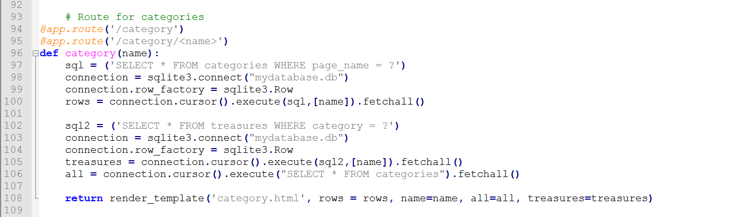

I really enjoyed working with Python and Flask. While doing both parts of the coursework, I have learned a few new skills. Now I am able to manage databases and functionality of server side files much better than before. I also feel much more comfortable with working with GitHub. I found it very useful tool as it allows me to access my coursework codes anywhere and anytime. It is also good tool for team work and managing files while working with other team members.

The programming in Python looked very complicated in the beginning but with some time and experience it became much easier and enjoyable that I expected.

# Application Screenshots

#### GitHub Main Page

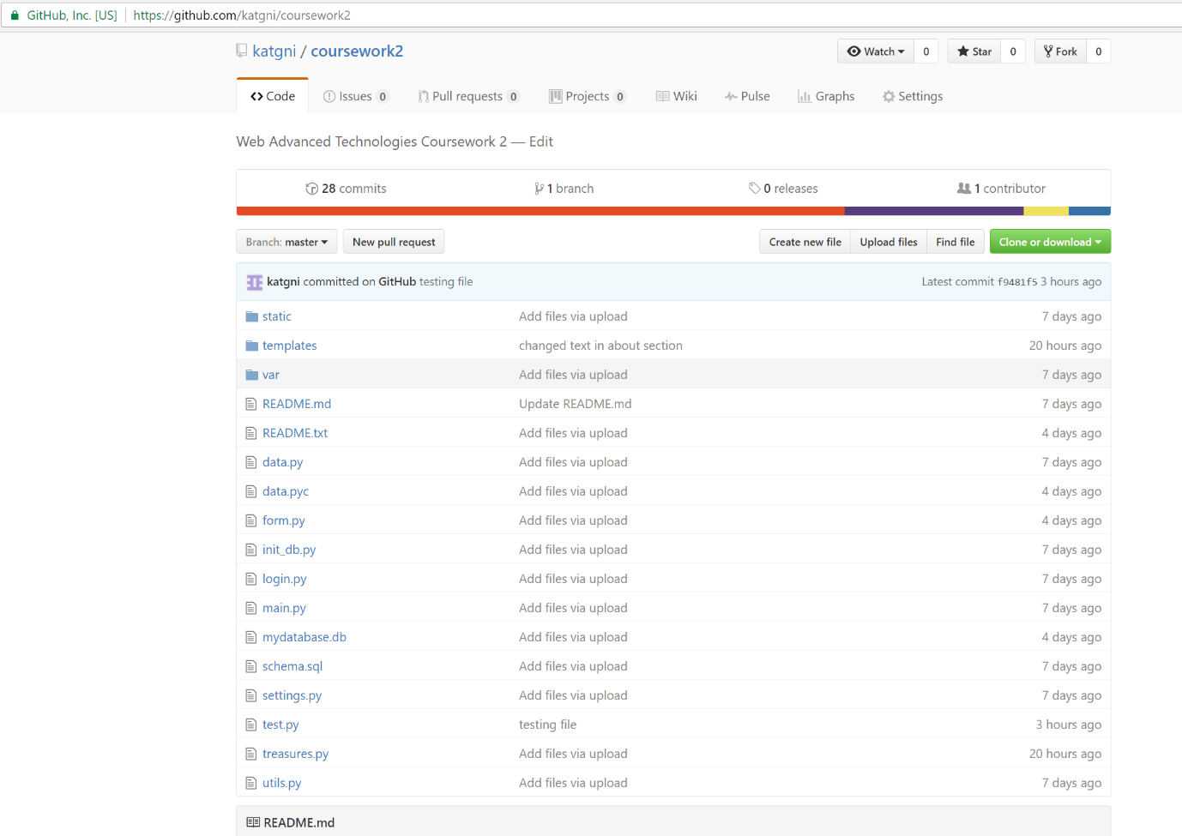

#### GitHub Static Folder

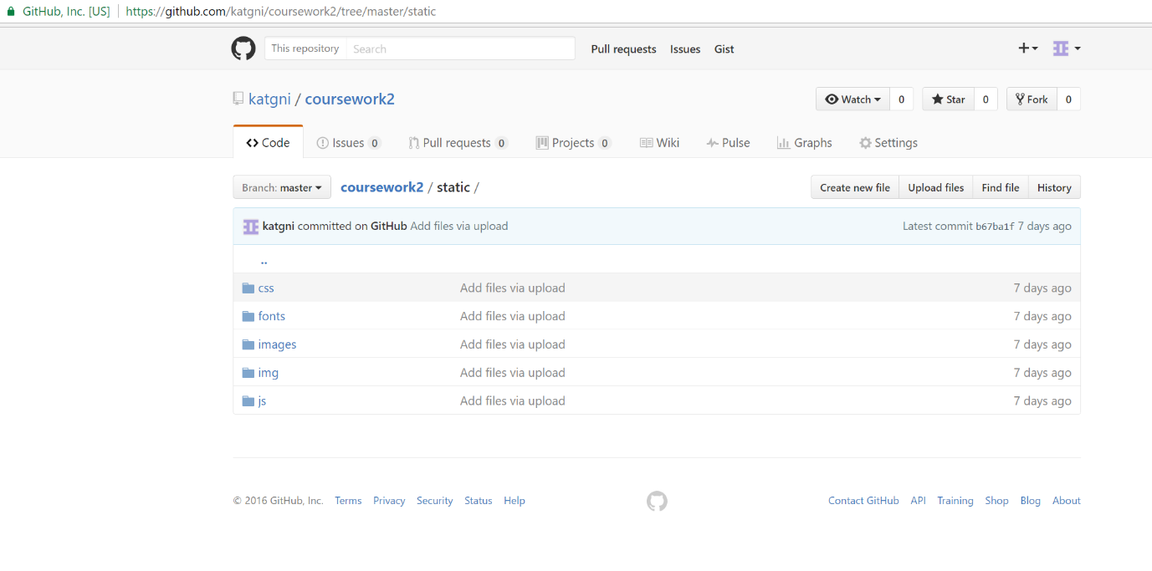

#### Index Page

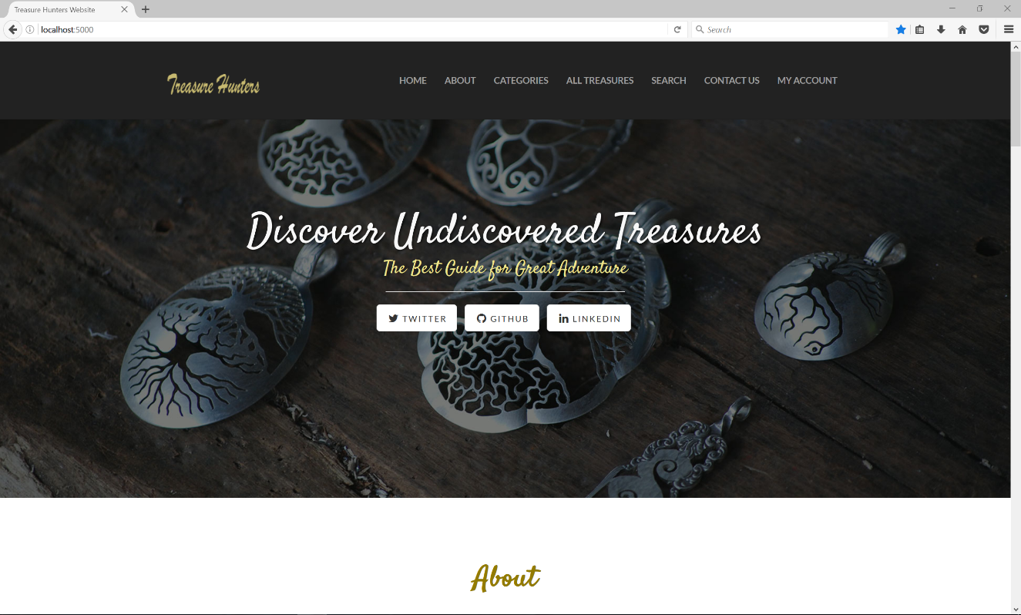

#### Categories Section on Index Page

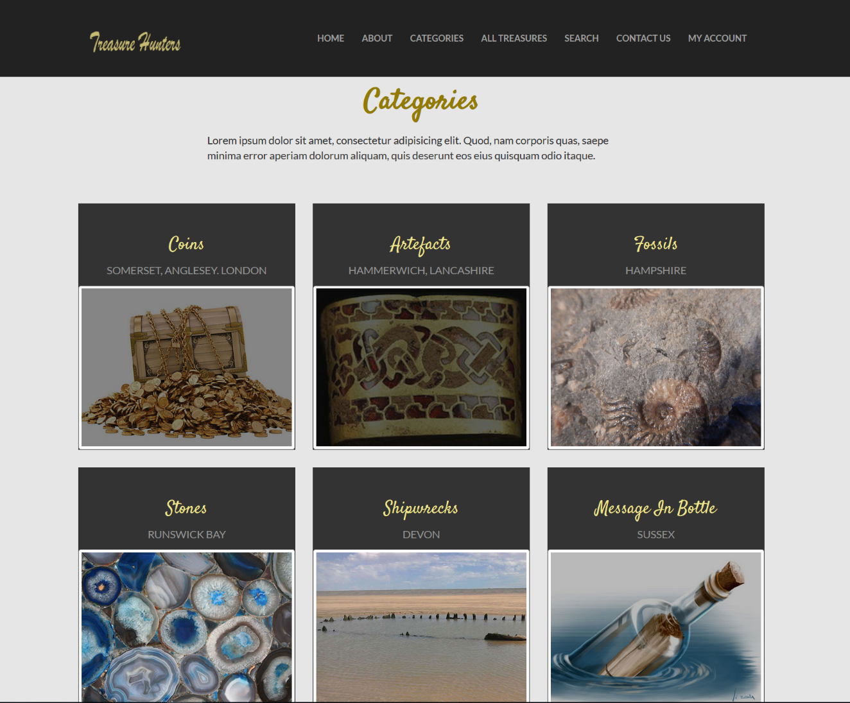

#### Contact Section on Index Page

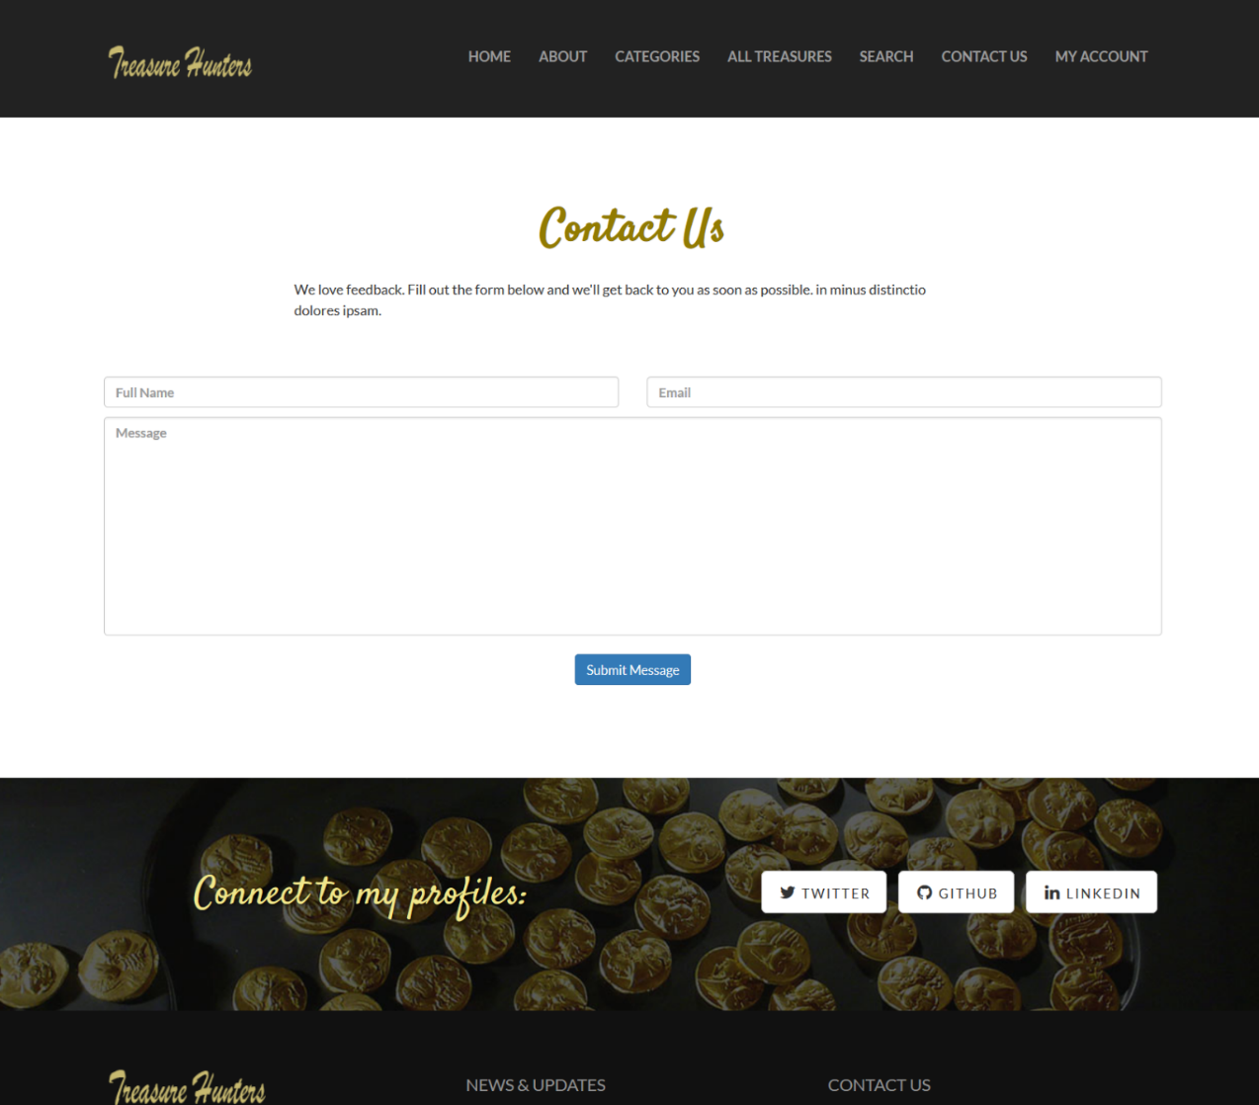

#### Login Page

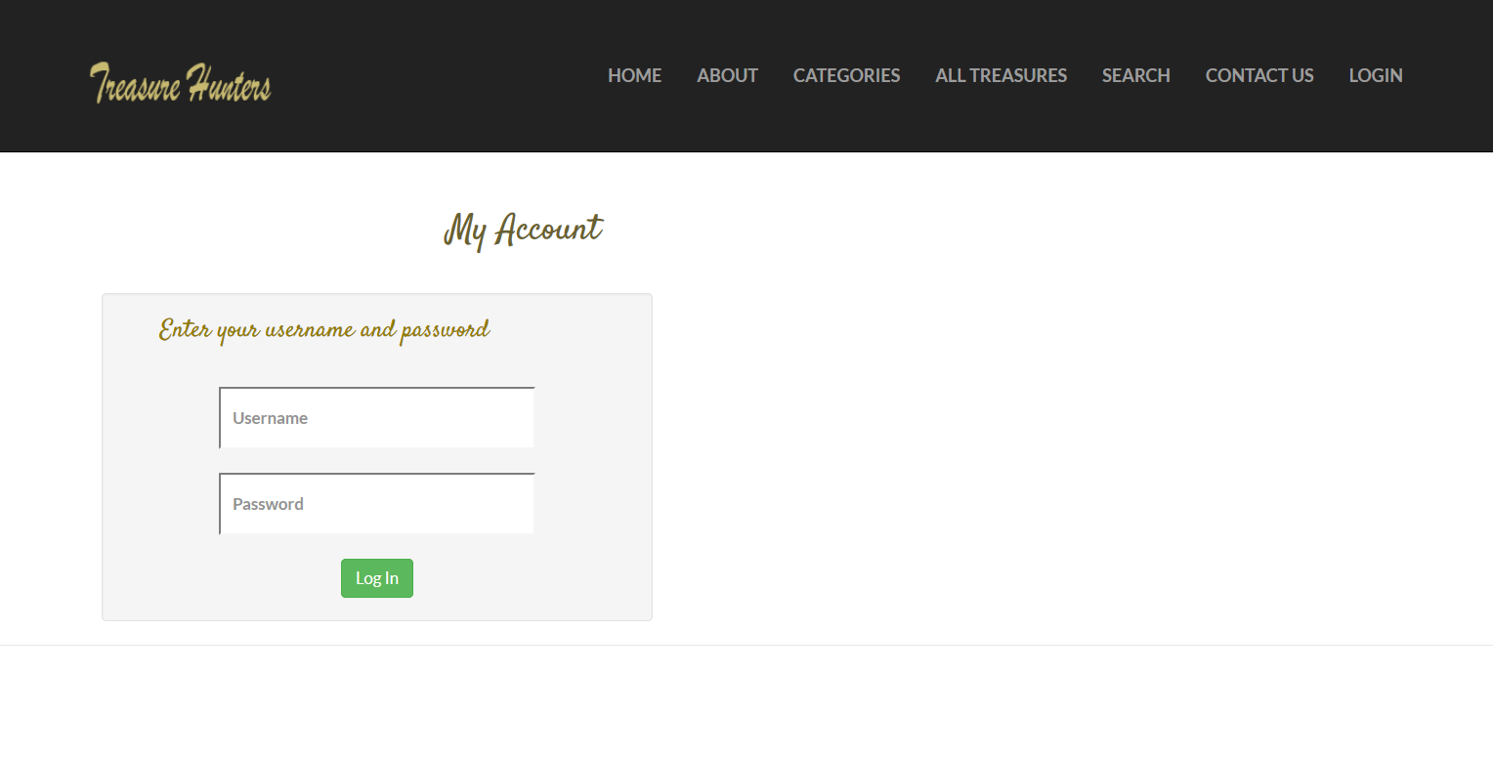

#### Logout Page

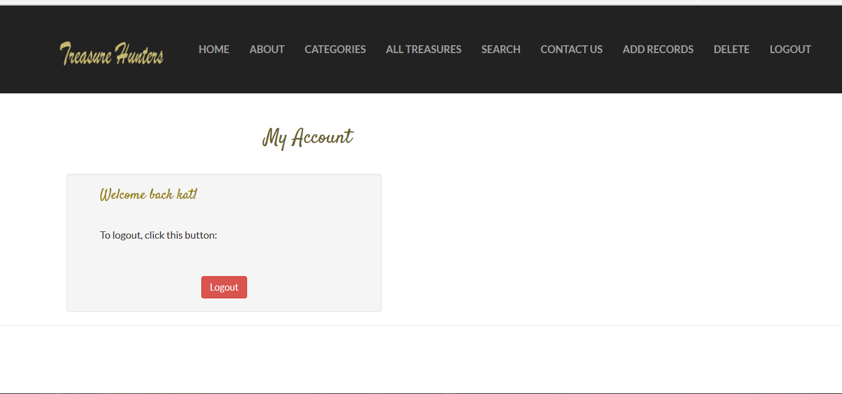

#### Search Page

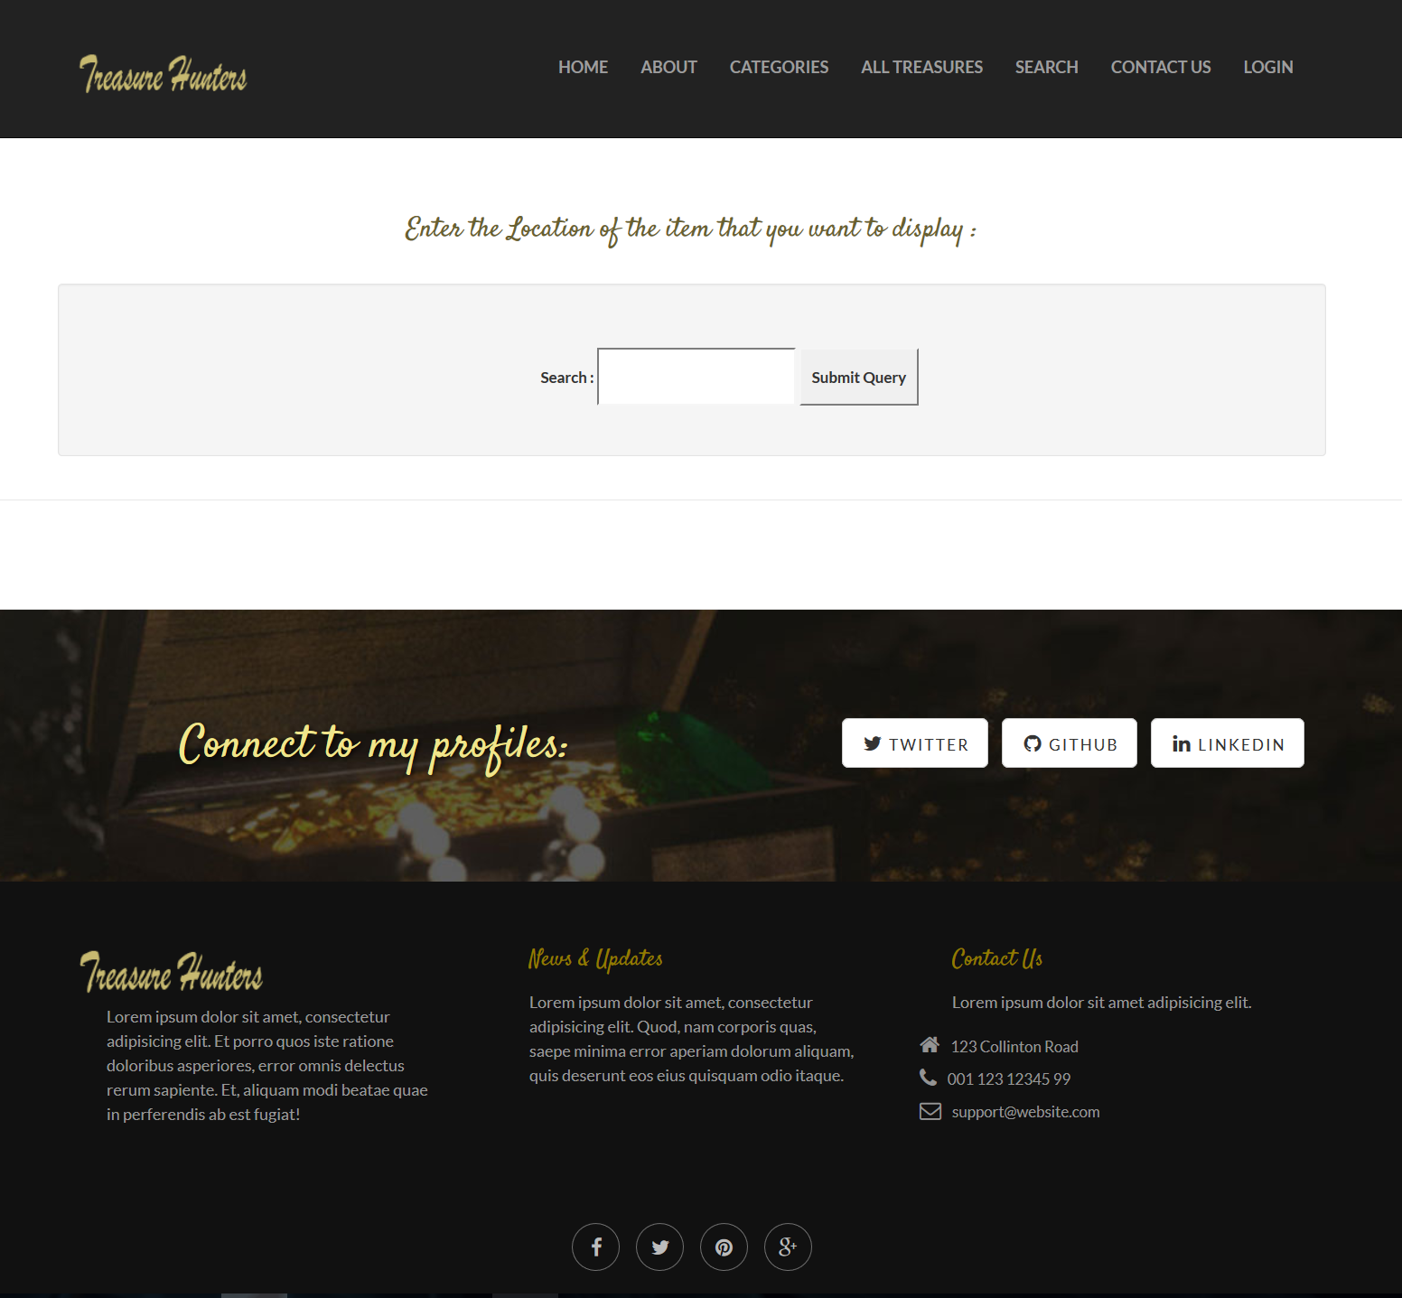

#### Add to Database (Admin Acdcess)

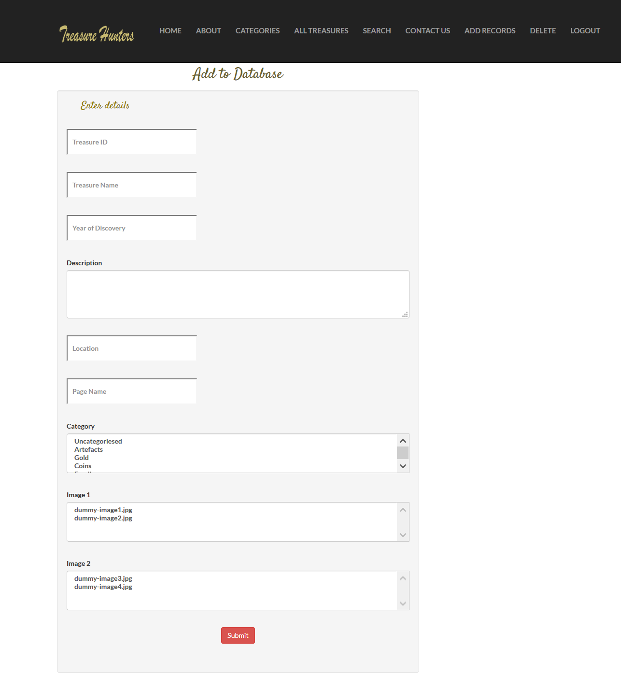

#### All items Page

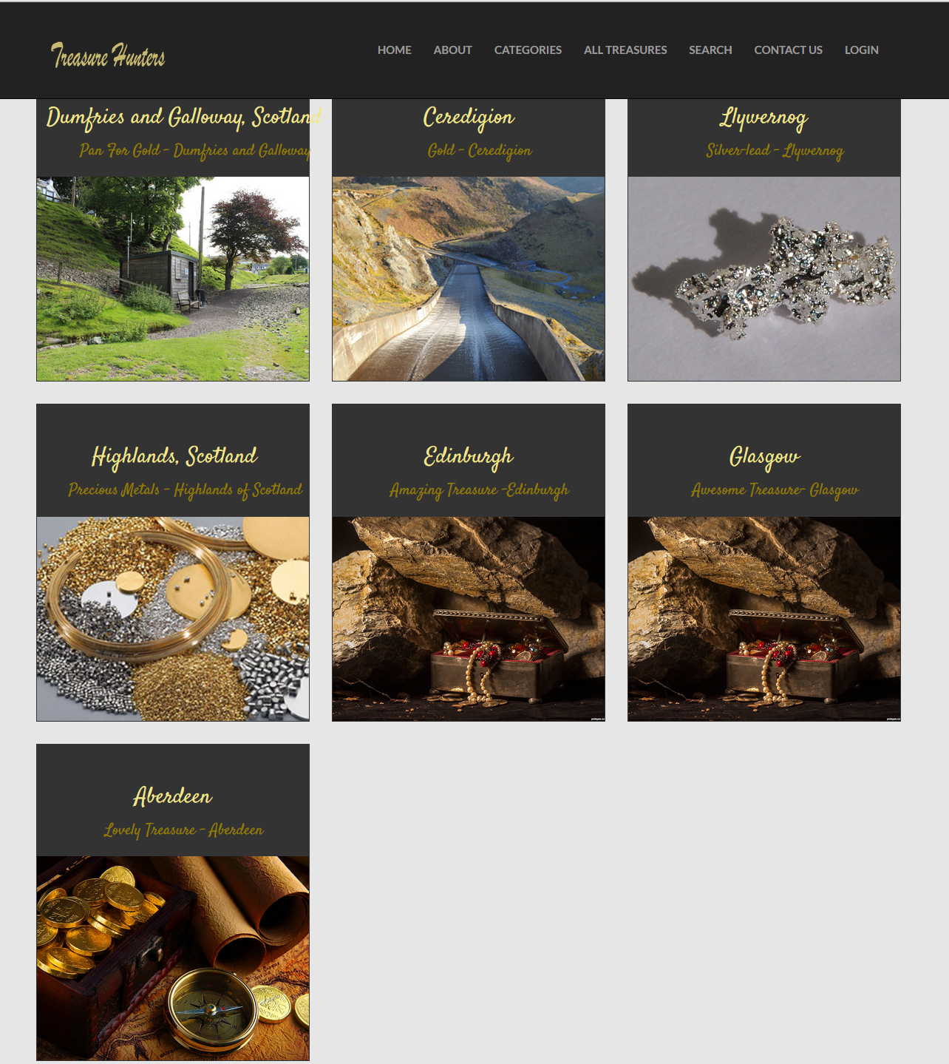

#### Delete from Database Page

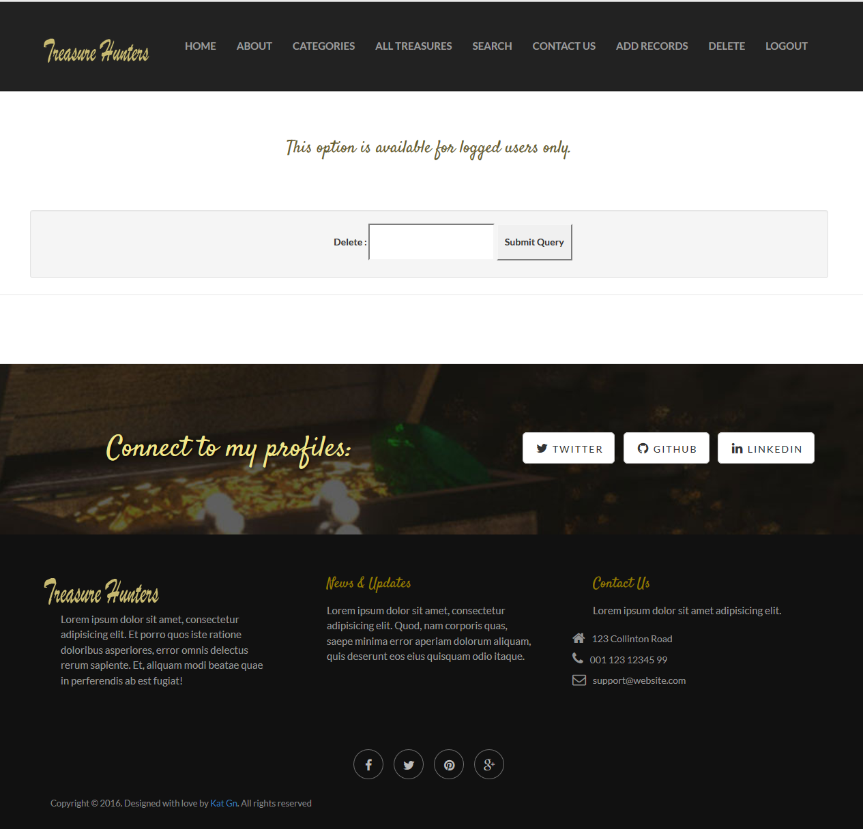

#### Delete from Database Page with All Database Records

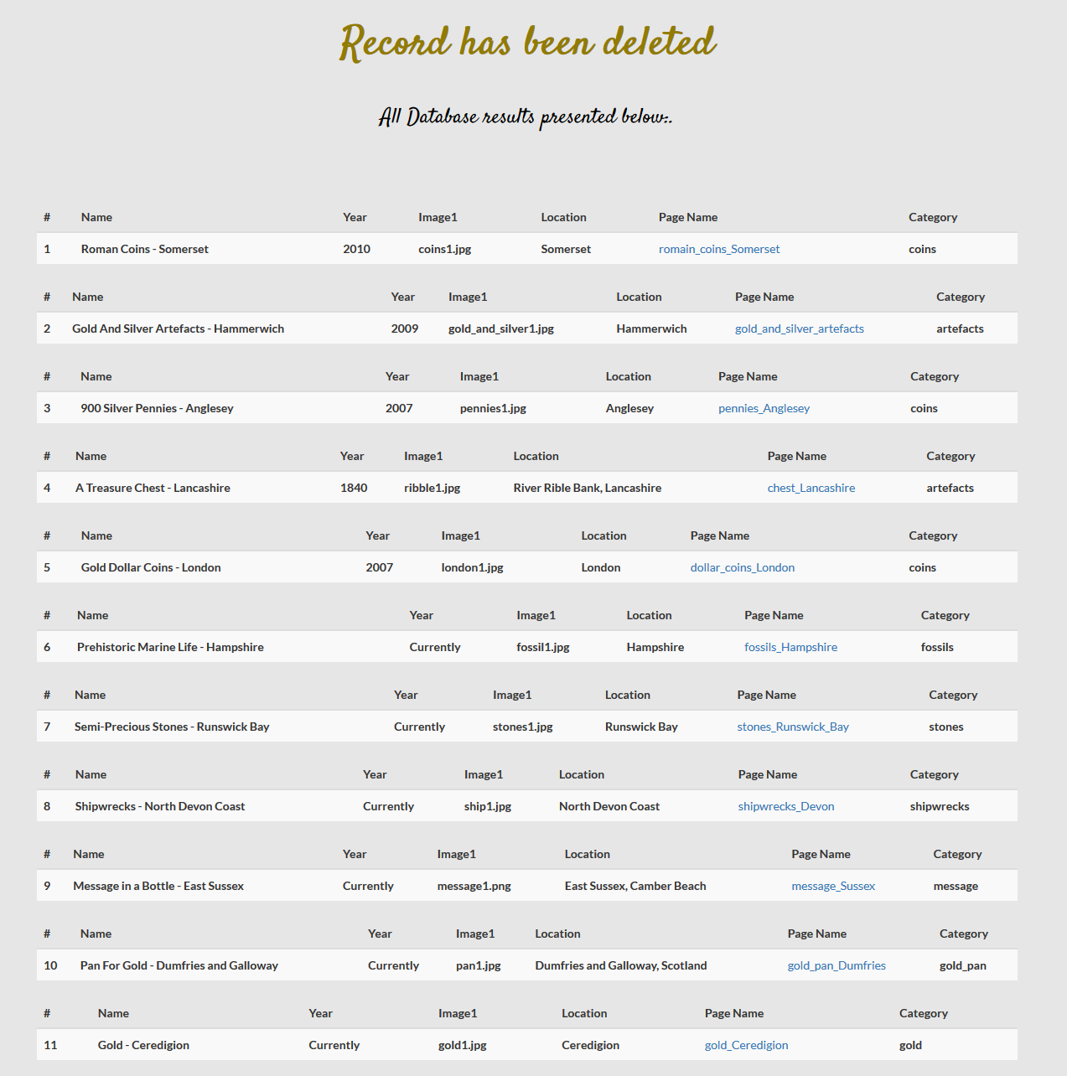

#### Database Screenshot (database.db)

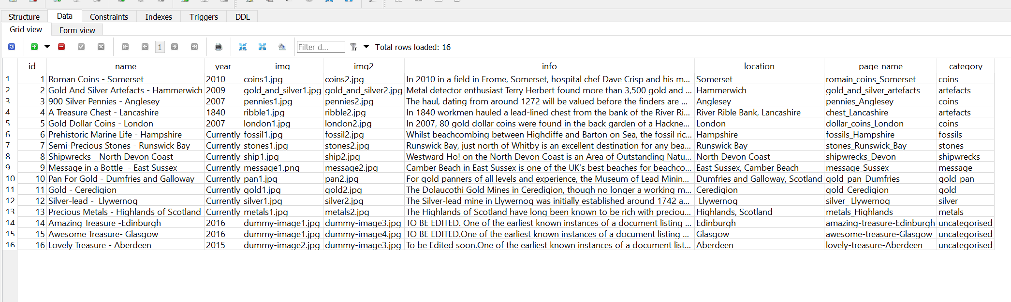

__________________________________________________________________________________

# References and Resources

1. ***Course source code, Accessed 04 November 2016***

<https://github.com/siwells/teaching_set09103>

1. ***Advanced Technologies Course website, Accessed 04 November 2016***

<http://siwells.github.io/teaching_set09103/>

1. ***SQLite3 Tutorial, Accessed 10 November 2016***

<https://www.tutorialspoint.com/flask/flask_sqlite.htm>

1. ***Flask Web Development with Python Tutorial - 7 - Passing Objects into Templates, Accessed 05 November 2016***

<https://www.youtube.com/watch?v=AOboS0RESt4&feature=youtu.be>

1. ***Creating a Web App from Scratch Using Python Flask and MySQL: Part 6, Accessed 30 October 2016***

<https://code.tutsplus.com/tutorials/creating-a-web-app-from-scratch-using-python-flask-and-mysql-part-6--cms-23402>

1. ***Learning Flask tutorial on Lynda.com, accessed 12 November 2016***

<http://codehandbook.org/working-with-json-in-python-flask/>

1. ***Discover Flask, Part 7 - Unit Tests, accessed 30 November 2016***

<https://www.youtube.com/watch?v=1aHNs1aEATg&t=3s>

1. ***How To Pin Point Multiple Locations On Google Maps, accessed 20 November 2016***

<https://www.create.net/support/218-how-to-pin-point-multiple-locations-on-google-maps.html>

1. ***Flask Tutorial Web Development with Python 19 - user login system, accessed 10 November 2016***

<https://www.youtube.com/watch?v=n2hLIfLHhOk>